Structural Design Patterns In Java
- Design

- Core Java

- java
by devs5003 - June 18, 20211
Last Updated on February 2nd, 2024
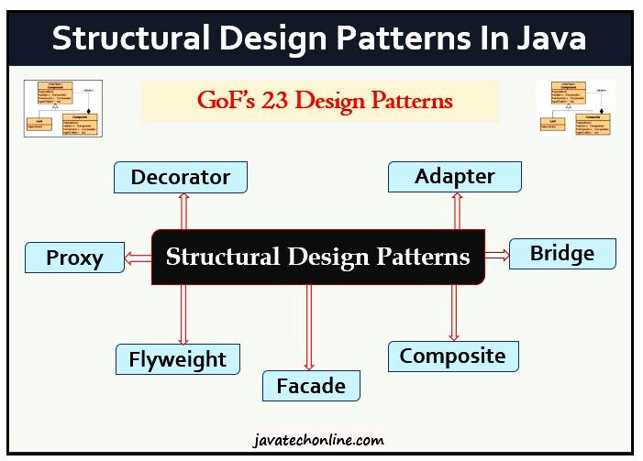In continuation of the first part of Design Patterns in Java, we will discuss about Structural Design Patterns In Java in this article. We have already covered Creational Design Patterns in Java in the first part as mentioned. The Structural Design Patterns deal with different ways to create a class structure. Moreover, they use Inheritance and Composition techniques to create larger objects from small objects. We will discuss seven design patterns in total in this article that come under the category of Structural Design Pattern. Let’s start discussing our topic ‘Structural Design Patterns In Java’.
Table of Contents
- What are Structural Design Patterns in Java?
- What are the types of Structural Design Patterns in Java?
- Composite Design Pattern
  - Objects in the Composite Pattern
  - Example
  - When to use Composite Pattern
  - Usage in JDK
- Adapter Design Pattern
  - Example
  - When to use Adapter Pattern
  - Adapter Pattern Example in JDK
- Proxy Design Pattern
  - Example
  - When to use the Proxy Pattern
  - Proxy Pattern in JDK
- Facade Design Pattern
  - Properties of Facade Pattern
  - Example
  - When to use
  - Usage in Java
- Bridge Design Pattern
  - Adapter Pattern vs Bridge Pattern
  - Example
  - When to Use and other points
  - Usage in JDK
- Decorator Design Pattern
  - Example
    - Component Interface
    - Component Implementation
    - Decorator
    - Concrete Decorators
  - When to use the Decorator Design Pattern
  - Usage in Java
- Flyweight Design Pattern
  - When to Use
  - Flyweight Pattern Example in JDK
- Links to Other Design Patterns
  - Creational Design Patterns
  - Behavioral Design Patterns
ADVERTISEMENT

What are Structural Design Patterns in Java?
Structural patterns provide different ways to create a class structure, for example, using inheritance and composition to create a large object from small objects.
What are the types of Structural Design Patterns in Java?
Following design patterns come under this category.
- Adapter Pattern
- Composite Pattern
- Proxy Pattern
- Flyweight Pattern
- Façade Pattern
- Bridge Pattern
- Decorator Pattern

Composite Design Pattern
There are times when you feel a need of a tree data structure in your code. However, there are many variations to the tree data structure, but sometimes there is a need for a tree in which both branches, as well as the leaves of the tree, should be treated uniformly.
The Composite Pattern allows you to compose objects into a tree structure to represent the part-whole hierarchy. It means you can create a tree of objects that is made of different parts, but that can be treated as a whole one big thing. Composite lets clients treat individual objects and compositions of objects uniformly, that’s the intent of the Composite Pattern.
In the composite pattern, a tree structure exists where identical operations can be performed on leaves and nodes. A node in a tree is a class that can have children. A node class is a ‘composite’ class. A leaf in a tree is a ‘primitive’ class that does not have children. The children of a composite can be leaves or other composites.
The leaf class and the composite class share a common ‘component’ interface that defines the common operations that can be performed on leaves and composites. When an operation on a composite is performed, this operation is performed on all children of the composite, whether they are leaves or composites. Hence, the composite pattern can be used to perform common operations on the objects that compose a tree.
Objects in the Composite Pattern
Base Component – Base component is the interface for all objects in the composition. Client program uses base component to work with the objects in the composition. Moreover, it can be an interface or an abstract class with some methods common to all the objects.
Leaf – Defines the behavior for the elements in the composition. It is the building block for the composition and implements base component. Although, it doesn’t have references to other Components.
Composite – It consists of leaf elements and implements the operations in base component.
Example
For example, let’s assume an organization hierarchy in terms of the Composite Pattern. Let’s assume Manager as Composite, Employee as Component, and Developer as the Leaf. First we will create component interface. It represents object in composition. It has all common operations that will be applicable to both manager and developer.
Employee.java
/**
* Manager(Composite)
* Developer(Leaf)
* Employee(Component)
*/
public interface Employee {

public void add(Employee emp);
public void remove(Employee emp);
public Employee getChild(int i);
public String getName();
public double getSalary();
public void print();
}
Manager.java
Now we will create Manager (composite class). The Key point here is that all common method delegates its operations to child objects. It has method to access and modify its children.
public class Manager implements Employee {

private String name;
private double salary;

public Manager(String name, double salary) {
this.name = name;
this.salary = salary;
}

List<Employee> employees = new ArrayList<Employee>();

@Override
public void add(Employee emp) {
employees.add(emp);
}

@Override
public void remove(Employee emp) {
employees.remove(emp);
}

@Override
public Employee getChild(int i) {
return employees.get(i);
}

@Override
public String getName() {
return name;
}

@Override
public double getSalary() {
return salary;
}

@Override
public void print() {
System.out.println("Name = " + getName());
System.out.println("Salary = " + getSalary());
System.out.println("-------------");

Iterator<Employee> empIterator = employees.iterator();
while(empIterator.hasNext()){
Employee emp= empIterator.next();
emp.print();
}
}
}
Developer.java
In this class, there are many methods which are not applicable to Developer because it is a leaf node.
public class Developer implements Employee {

private String name;
private double salary;

public Developer(String name,double salary){
this.name = name;
this.salary = salary;
}

@Override
public void add(Employee emp) {
// this is leaf node so this method is not applicable to this class.
}

@Override
public void remove(Employee emp) {
// this is leaf node so this method is not applicable to this class.
}

@Override
public Employee getChild(int i) {
// this is leaf node so this method is not applicable to this class.
return null;
}

@Override
public String getName() {
return name;
}

@Override
public double getSalary() {
return salary;
}

@Override
public void print() {
System.out.println("Name = " +getName());
System.out.println("Salary = " +getSalary());
System.out.println("-------------");
}
}
CompositePatternTest.java
public class CompositePatternTest {

public static void main(String[] args) {

Employee emp1 = new Developer("Robert", 10000);
Employee emp2 = new Developer("David", 15000);
Employee manager1 = new Manager("Mark", 25000);
manager1.add(emp1);
manager1.add(emp2);
Employee emp3 = new Developer("Mary", 20000);
Manager generalManager = new Manager("John", 50000);
generalManager.add(emp3);
generalManager.add(manager1);
generalManager.print();

}
}
Output
Name =John
Salary =50000.0
-------------
Name =Mary
Salary =20000.0
-------------
Name =Mark
Salary =25000.0
-------------
Name =Robert
Salary =10000.0
-------------
Name =David
Salary =15000.0
-------------
When to use Composite Pattern
Below is the conditions when we can use this pattern:
- When we want to represent part-whole hierarchies of objects.
- When we want clients to be able to ignore the difference between compositions of objects and individual objects. Clients will treat all objects in the composite structure uniformly.
Usage in JDK
java.awt.Container#add (Component) is a great example of Composite pattern in java and used a lot in Swing.
Here, we have completed the first design pattern of our article ‘Structural Design Patterns In Java’.

